EXPT NO:3 | CLEANSE DATA BY HANDLING MISSING VALUES, OUTLIERS, AND INCONSISTENCIES USING TABLEAU AND POWERBI
DATE: 10.07.2026

PRE-LAB QUESTIONS (PROVIDE BRIEF ANSWERS TO THE FOLLOWING QUESTIONS)

- What are the potential impacts of missing values in a dataset, and what are some common strategies to address them in Tableau and Power BI?
Missing values reduce the accuracy and reliability of data analysis because they can produce incorrect summaries, misleading visualizations, and poor decision-making. They may also affect calculations such as averages, totals, and trends. In Tableau, missing values can be handled using calculated fields like IFNULL() or by replacing them with suitable default values. In Power BI, Power Query and DAX functions such as IF(ISBLANK()) are commonly used to replace missing numerical values with zero, mean, or median, and text values with labels like Unknown.

- What is the importance of identifying and addressing outliers in a dataset? How can outliers affect data analysis and model performance?
Outliers are unusually high or low values that differ significantly from the rest of the data. They can distort statistical measures such as the mean, create misleading visualizations, and negatively affect predictive models. Identifying outliers helps analysts determine whether they represent valid observations or data entry errors. Tableau and Power BI provide scatter plots, box plots, and calculated fields that make it easier to detect, flag, and analyze outliers before making important business decisions.

- What types of data inconsistencies might you encounter during data cleansing, and how can Tableau and Power BI help in resolving them?
Common data inconsistencies include different spellings of the same category, inconsistent capitalization, duplicate labels, blank text values, and varying date or currency formats. These inconsistencies can divide similar records into separate groups and reduce reporting accuracy. Tableau provides features such as Groups, Aliases, and calculated fields to standardize values, while Power BI offers Power Query tools like Replace Values, Transform Data, and formatting options to clean and normalize data efficiently before analysis.

- How do you identify patterns in data using visualizations to spot missing values, outliers, and inconsistencies?
Visualizations make unusual data patterns easier to recognize than raw tables. Scatter plots highlight extreme values that appear far from the main cluster, while histograms and bar charts reveal unusual distributions and missing categories. Heatmaps and tables help identify blank or inconsistent values across multiple fields. By comparing charts before and after cleaning, analysts can verify that missing values, outliers, and inconsistencies have been corrected, resulting in more reliable and meaningful business insights.

- What is the role of calculated fields in data cleansing, and how can they be used to handle missing values and outliers in Tableau/Power BI?
Calculated fields allow users to create new values without modifying the original dataset. During data cleansing, they are useful for replacing missing values, identifying outliers, standardizing data, and creating validation columns. In Tableau, functions such as IFNULL() can replace null values with meaningful defaults. In Power BI, DAX expressions using IF() and ISBLANK() perform similar tasks. Calculated fields also help flag abnormal records for further investigation while preserving the original data.
IN-LAB EXERCISE:
OBJECTIVE:
To clean a given dataset (e.g., Superstore Sample in Tableau and Financials/Sales Data in Power BI) by identifying and resolving missing values, outliers, and inconsistencies using built-in tools, ensuring the dataset is accurate and ready for analysis.
PROCEDURE:
  - Open the Tool and Connect Dataset o Open Tableau Desktop , Power BI Desktop.
    - Load the built-in dataset (Sample - Superstore in Tableau / Financials in Power BI).
    - Preview the dataset to understand its structure.
  - Initial Inspection o Explore fields such as Sales, Profit, Region, or Product Category.
    - Check for nulls, inconsistent text values (e.g., "South Region" vs. "South"), or date formatting issues.
  - Handling Missing Values o Use Data Interpreter (Tableau) / Power Query (Power BI) to highlight nulls. o Replace missing numerical values with mean/median, and text with "Unknown".
    - Use calculated fields: IFNULL([Field], Default) in Tableau or IF(ISBLANK([Field]), "Unknown", [Field]) in Power BI.
  - Detecting and Managing Outliers o Create scatter or box plots for Sales and Profit to identify extreme values.
    - Choose strategies:
      - Filter them temporarily.
      - Apply caps using calculated columns.
      - Flag them with labels for review.
  - Resolving Inconsistencies o Use Group/Alias (Tableau) / Replace Values (Power BI) to standardize text.
    - Normalize data formats, such as date fields or currency units.
- Validation with Visuals
    - Build dashboards with histograms, bar charts, and box plots to visually confirm improvements.
    - Compare before/after cleaning stages for accuracy.
- Save the Cleaned Dataset o Save as .twbx (Tableau) / .pbix (Power BI).
o Optionally export cleaned data to .csv.
- Summary Dashboard
o Create a visual summary of the cleaning process, highlighting:
      - Fields corrected.
      - Nulls/outliers removed or adjusted.
      - Clean dataset metrics (record count, completeness %).

Experiment Dataset:
  - Tableau: Sample - Superstore
  - Power BI: Financials or Sales Data
How to Access:
Tableau:
  - Navigate to: Start Page → Sample Workbooks
  - Or: Help → Sample Data → Open Sample Data Folder
Power BI:
  - Navigate to: Home → Get Data → Excel → Choose sample datasets (e.g., Financial Sample.xlsx)
  - Microsoft also hosts Power BI sample datasets online.
Fields Used:
  - Sales
  - Profit
  - Region
  - Category
  - Order Date / Transaction Date

Screenshot of output from Tableau:

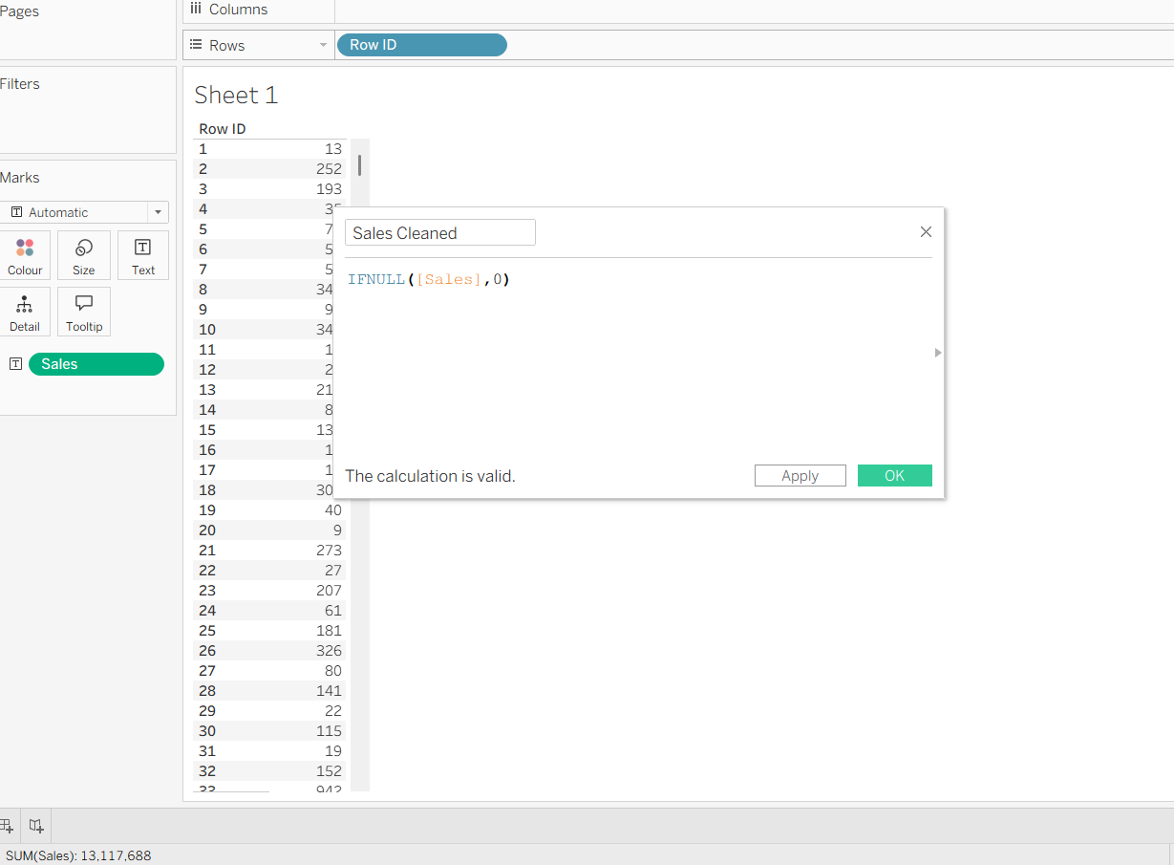

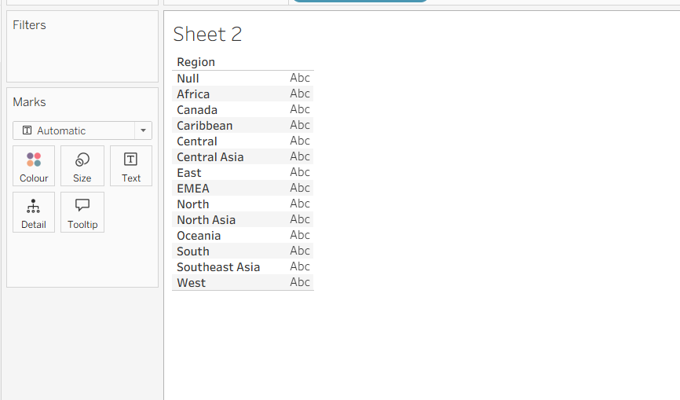

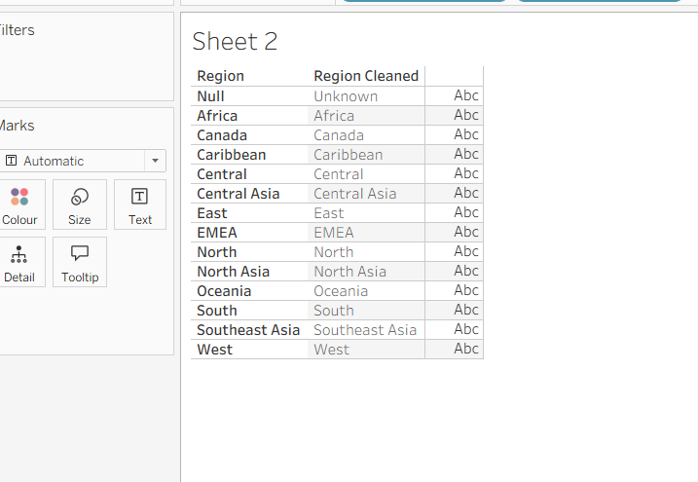

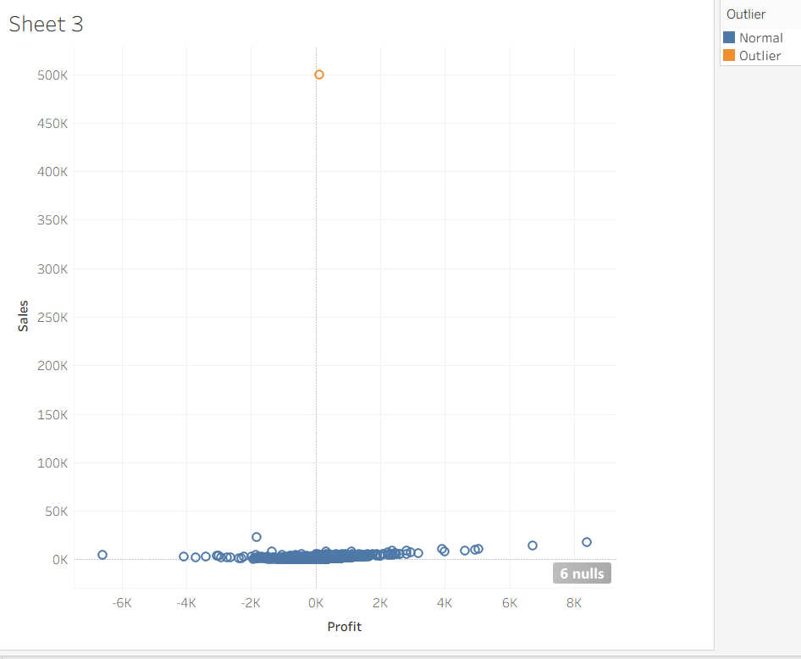
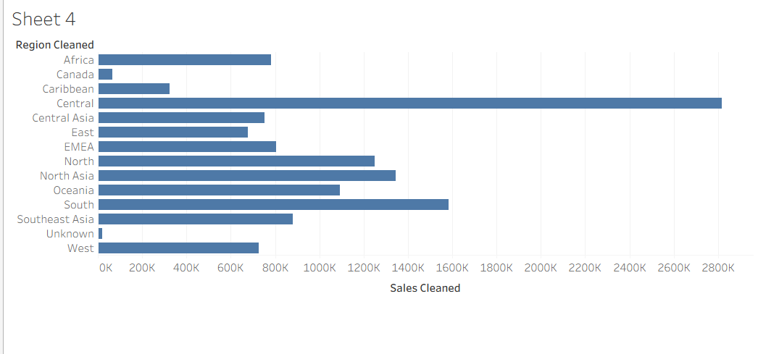

Screenshot of output from Tableau:
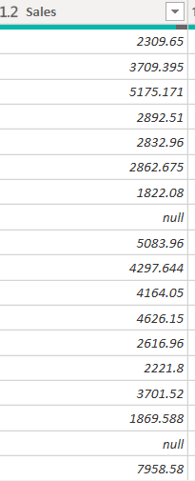
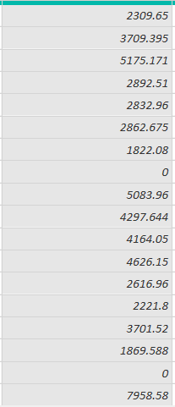
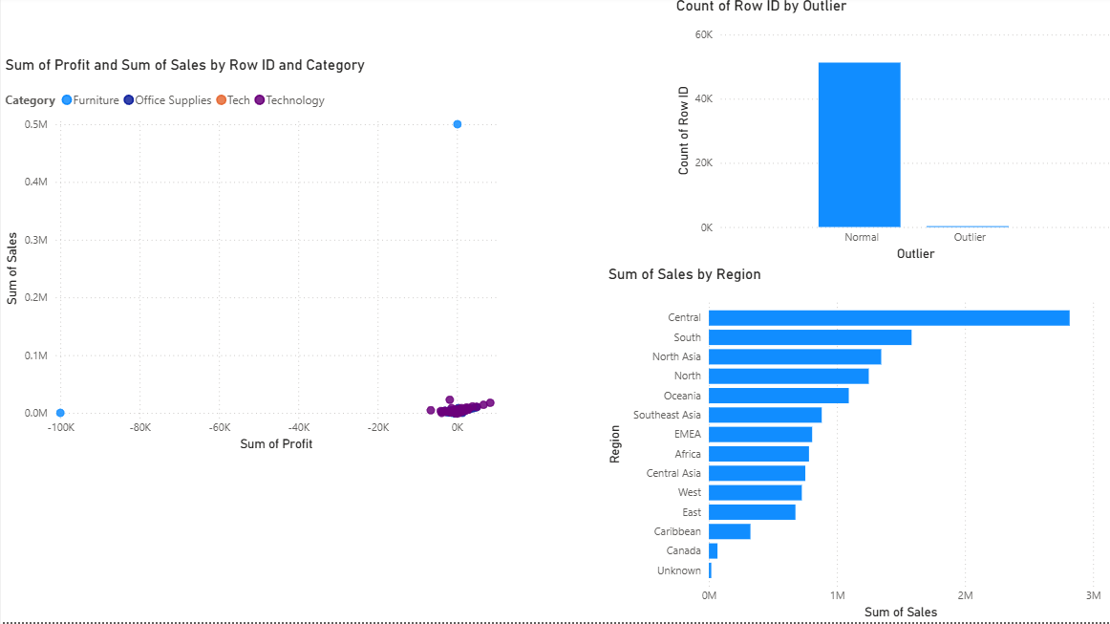

POST-LAB QUESTIONS (PROVIDE BRIEF ANSWERS TO THE FOLLOWING QUESTIONS)
- What method did you use to replace missing values in numeric fields?
During this experiment, missing numerical values in the Sales field were replaced with 0 to ensure that calculations and visualizations remained complete. In Tableau, a calculated field using IFNULL([Sales], 0) was created, while in Power BI, missing values were replaced through Power Query or equivalent DAX logic. Missing text values in the Region field were replaced with Unknown, ensuring that every record could be included in reports without causing errors or incomplete visualizations.

- How were outliers handled in your dataset and what visual confirmed their correction?
Outliers were identified using a scatter plot comparing Sales and Profit, where extreme values appeared far from the main group of records. Instead of deleting these observations, they were flagged using calculated fields so they could be reviewed separately. This approach preserved the original data while making unusual records easy to identify. The scatter plot clearly confirmed the presence of the outliers and demonstrated that they had been successfully highlighted for further analysis.

- What inconsistencies were detected in categorical values and how were they standardized?
Several categorical inconsistencies were intentionally introduced into the dataset, including values such as "Central Region", "South Region", "Tech", and "Std Class." These were standardized to "Central", "South", "Technology", and "Standard Class" using Tableau's Alias and Group features or the Replace Values function in Power BI. Standardizing these values ensured that identical categories were grouped together correctly, improving the accuracy of charts, summaries, and dashboard reports.
- Describe how calculated fields helped in resolving data issues.
Calculated fields simplified the data cleaning process by automatically replacing missing values, identifying outliers, and generating clean versions of existing fields without changing the original dataset. In Tableau, calculated fields using IFNULL() replaced null values, while Power BI used DAX expressions such as IF() and ISBLANK() to achieve similar results. Additional calculated fields were created to label outliers, making it easier to analyze, filter, and validate cleaned data throughout the visualization process.

- How did your dashboard demonstrate the effectiveness of the data cleaning process?
The dashboard combined scatter plots, bar charts, KPI cards, and summary visuals to demonstrate the improvements made during data cleansing. It showed that missing values had been replaced, inconsistent category names had been standardized, and outliers had been identified for review. Comparing the cleaned data with the original dataset confirmed that the information was now more complete, consistent, and suitable for analysis. The dashboard provided a clear overview of the entire cleaning process and supported accurate business decision making.

RESULT:

The dataset was successfully cleaned and prepared for accurate analysis using Tableau and Power BI. Issues such as nulls, inconsistencies, and outliers were identified and resolved, improving data quality significantly.

ASSESSMENT

Description |  | Max Marks | Marks Awarded
Pre Lab Exercise |  | 5
In Lab Exercise |  | 10
Post Lab Exercise |  | 5
Viva |  | 10
 | Total | 30
 |  | Faculty Signature

